ECA0901 – DIGITAL SIGNAL PROCESSING

C01 – AT3 SIMULATION EXPERIMENT – 6
Design and Analysis of FIR Digital Filters Using Fourier Series and Windowing MATLAB
CODE:
clc;
clear;
close all;
% Input specifications
Fs = 1000;
Fp = 100;
Fst = 150;
Ap = 1;
Ast = 40;
N = 20;

% Cutoff frequency
Fc = (Fp + Fst)/2;
Wn = Fc/(Fs/2);

% Window functions
w1 = ones(N+1,1);
w2 = hamming(N+1);
w3 = hann(N+1);
w4 = blackman(N+1);

% FIR filter design
h1 = fir1(N,Wn,'low',w1);
h2 = fir1(N,Wn,'low',w2);
h3 = fir1(N,Wn,'low',w3);
h4 = fir1(N,Wn,'low',w4);

% Display filter coefficients
disp('Rectangular Window Coefficients');
disp(h1);

disp('Hamming Window Coefficients');
disp(h2);

disp('Hanning Window Coefficients');
disp(h3);

disp('Blackman Window Coefficients');
disp(h4);

% Frequency response
[H1,f] = freqz(h1,1,2048,Fs);
[H2,~] = freqz(h2,1,2048,Fs);
[H3,~] = freqz(h3,1,2048,Fs);
[H4,~] = freqz(h4,1,2048,Fs);

% Magnitude response in dB
figure;

subplot(2,1,1);
plot(f,20*log10(max(abs(H1),1e-6)),'r');
hold on;
plot(f,20*log10(max(abs(H2),1e-6)),'b');
plot(f,20*log10(max(abs(H3),1e-6)),'g');
plot(f,20*log10(max(abs(H4),1e-6)),'k');
grid on;
xlabel('Frequency (Hz)');
ylabel('Magnitude (dB)');
title('Magnitude Response of FIR Filters');
legend('Rectangular','Hamming','Hanning','Blackman');
xlim([0 Fs/2]);
ylim([-100 5]);

% Phase response
subplot(2,1,2);
plot(f,unwrap(angle(H1)),'r');
hold on;
plot(f,unwrap(angle(H2)),'b');
plot(f,unwrap(angle(H3)),'g');
plot(f,unwrap(angle(H4)),'k');
grid on;
xlabel('Frequency (Hz)');
ylabel('Phase (radians)');
title('Phase Response of FIR Filters');
legend('Rectangular','Hamming','Hanning','Blackman');
xlim([0 Fs/2]);

% Individual filter responses
figure;
freqz(h1,1,2048,Fs);
title('Rectangular Window');

figure;
freqz(h2,1,2048,Fs);
title('Hamming Window');

figure;
freqz(h3,1,2048,Fs);
title('Hanning Window');

figure;
freqz(h4,1,2048,Fs);
title('Blackman Window');

% Window comparison
figure;
plot(0:N,w1,'r-o');
hold on;
plot(0:N,w2,'b-o');
plot(0:N,w3,'g-o');
plot(0:N,w4,'k-o');
grid on;
xlabel('Sample index n');
ylabel('Amplitude');
title('Comparison of Window Functions');
legend('Rectangular','Hamming','Hanning','Blackman');

OUTPUT:
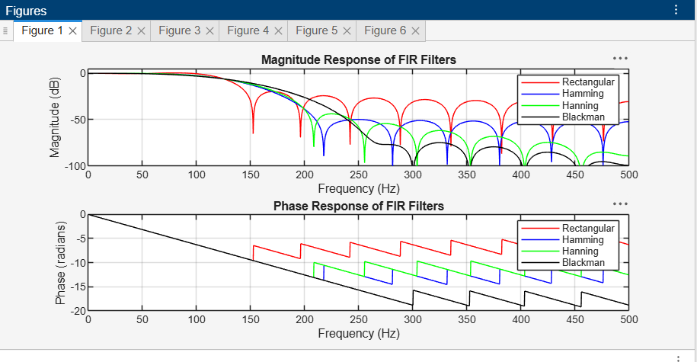

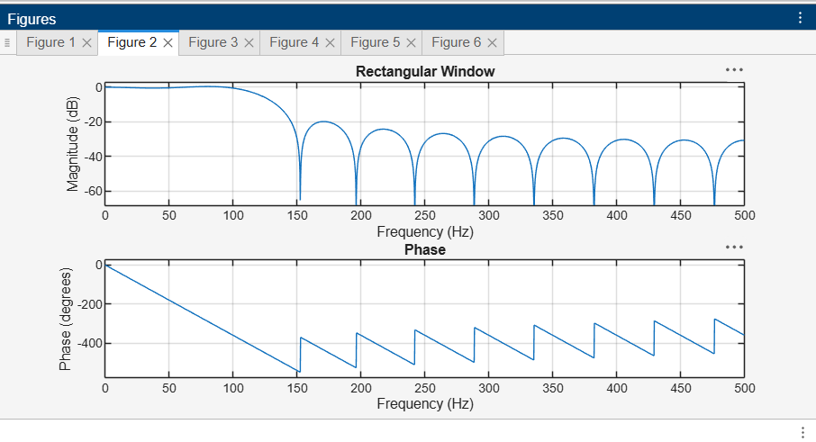

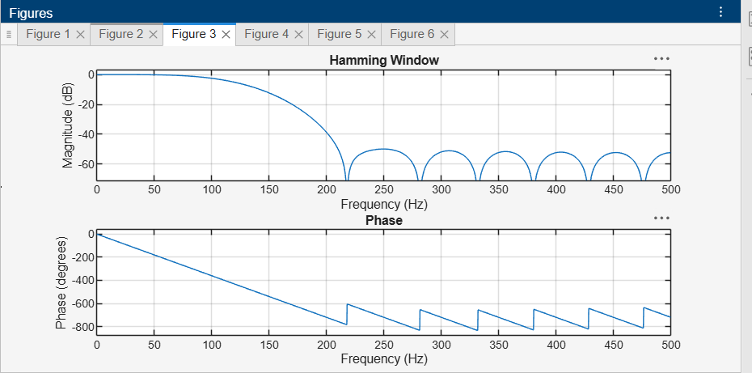

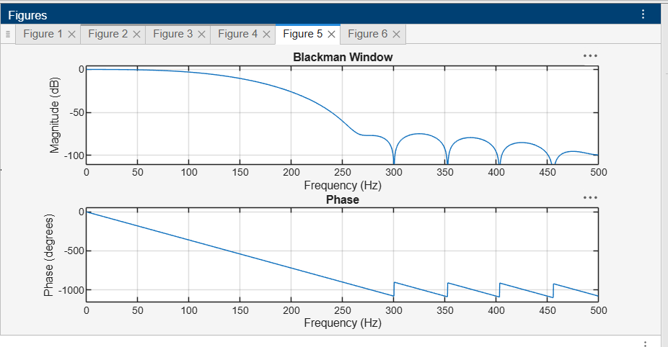

OUTPUT PARAMETERS:

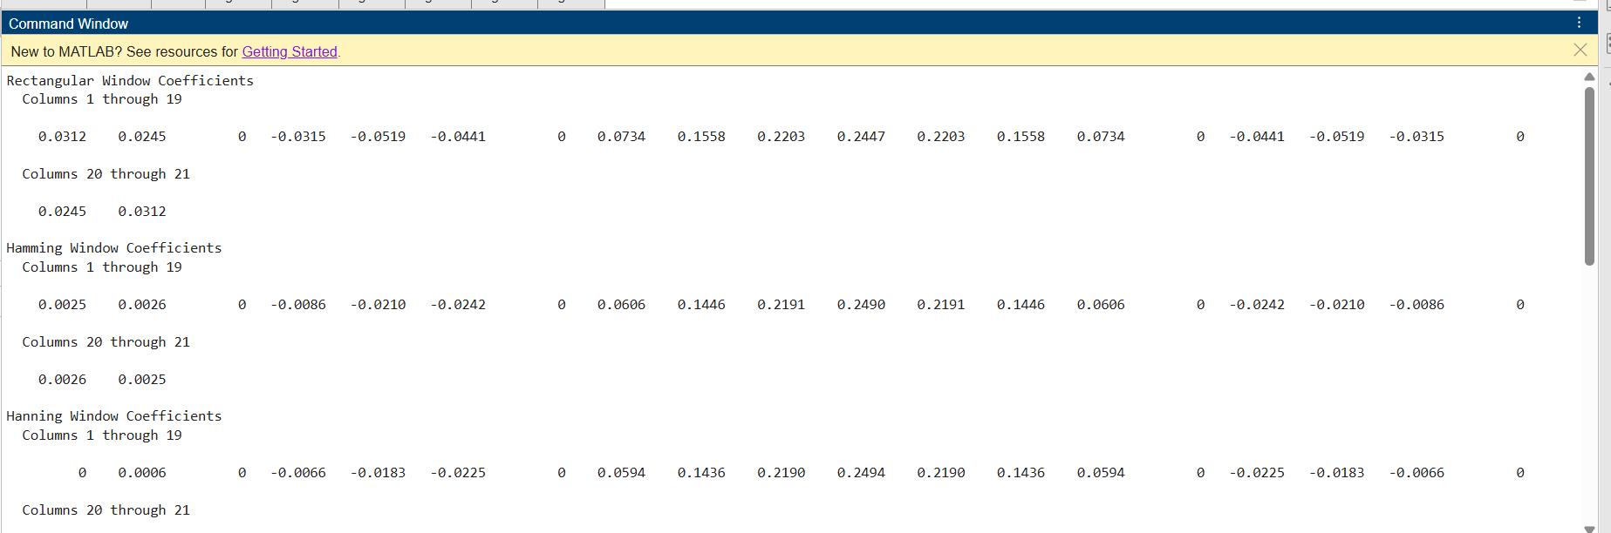

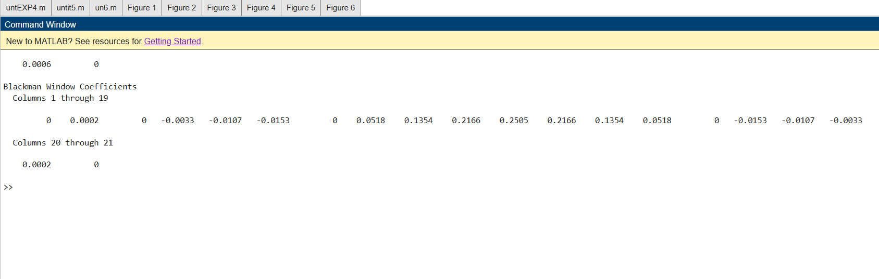

RESULT:
Thus, FIR low-pass digital filters were designed using the Fourier-series/windowing method in MATLAB with Rectangular, Hamming, Hanning, and Blackman windows. Their coefficients, magnitude responses, phase responses, and transition characteristics were obtained and compared.

